The Morris Educational Foundation, in partnership with the
Morris School District’s Office of the Superintendent, is proud to present
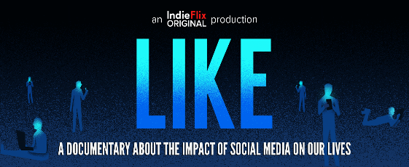

"Like" Film Screening & Panel Discussion:
A documentary and discussion about the impact of social media on our lives.

The goal for this film is to inspire people of all ages, especially kids, to self-regulate.
As technology continues to progress, and children are exposed at even earlier ages,
education and discussion are critical to understanding how it affects us
and how we can manage it going forward.
Special introduction by Superintendent Mackey Pendergrast

Tuesday, April 30, 2019
7:00 pm – 9:00 pm
Frelinghuysen Middle School Auditorium

Specially Selected Panelists Include:
- Dr. Michael Osit – Psychologist, author, & expert on the psychological effects of technology on youth
- Matthew Krayton - Adjunct Professor, Centenary University’s Social Media Center of Expertise
- Erica Hartman - MSD Director of Technology Integration
- MHS Student & FMS Student
Moderated by: Debora Engelfried, MSD Supervisor of Social Emotional Learning & Information Mgmt.

This program is appropriate for ALL parents
Students 10+ are welcome and encouraged to attend
Please Register Here
Register & attend for a chance to win a book on this topic

