Green Brook Township Public Schools
Green Brook, New Jersey 08812

Green Brook Middle School
OFFICE OF THE PRINCIPAL (732) 968-1051
132 Jefferson Avenue

May 29, 2015

Dear Parent/Guardian:

To determine your child’s appropriate math placement for 2015-2016 school year, we are beginning our assessment process. Students in the advanced math program have the opportunity to leave GBMS having completed Algebra One and/or Geometry. Because your child is currently in the advanced math program, teacher recommendation, classroom performance, and the end of the year achievement test (Final Exam) will be used in determining appropriate placement.

If you have any questions, please do not hesitate to contact me.

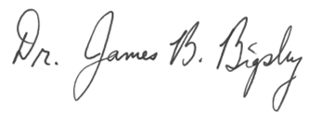
Sincerely,

Dr. James B. Bigsby

