Green Brook Township Public Schools
Green Brook, New Jersey 08812

Green Brook Middle School
OFFICE OF THE PRINCIPAL (732) 968-1051
132 Jefferson Avenue

May 29, 2015

Dear Parent/Guardian:

To determine your child’s math placement for 6th grade, we are beginning our placement process. In addition to teacher recommendation and classroom performance, the following criteria will be used in determining eligibility:

Cognitive Abilities Test, Algebra Aptitude Assessment, and End of Year Achievement Test

The following are the dates of the assessments/tests:
CogAt - Administered on March 10th
End of Year Achievement Test - June 3rd
Algebra Aptitude Assessment - June 4th

Make Ups will be scheduled at a later date.

If you have any questions, please do not hesitate to contact me.

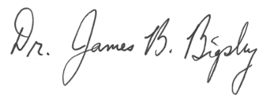
Sincerely,

Dr. James B. Bigsby

