Green Brook Township Public Schools
Green Brook, New Jersey 08812

Green Brook Middle School
OFFICE OF THE PRINCIPAL (732) 968-1051
132 Jefferson Avenue

May 29, 2015

Dear Parent/Guardian:

To determine your child’s math placement for 6th grade, we are beginning our placement process. In addition to teacher recommendation and classroom performance, the following criteria will be used in determining eligibility:

Cognitive Abilities Test, Algebra Aptitude Assessment, and End of Year Achievement Test

The following are the dates of the assessments/tests:
CogAt - Administered on March 10th
Algebra Aptitude Assessment - June 9th (9:00 AM – 10:00 AM)
End of Year Achievement Test – June 10th (9:00 AM – 10:30 AM)

Make Ups will be scheduled at a later date.

Please sign and return the attached permission form for participation by June 5th.

If you have any questions, please do not hesitate to contact me.

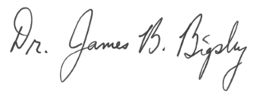
Sincerely,

Dr. James B. Bigsby

6th Grade Advanced Math Program

PARENT/GUARDIAN: Please complete and return to your FIFTH GRADE teacher by Friday, June 5th.

I would like my son/daughter __________________________ to participate in the Advanced Math process.

_______________________________
Parent/guardian name PRINTED

_______________________________
Parent/guardian signature

